**Project Title: Estimate the Crop Yield using Data Analysis**

**Project Design Phase-I - Solution Fit Template**

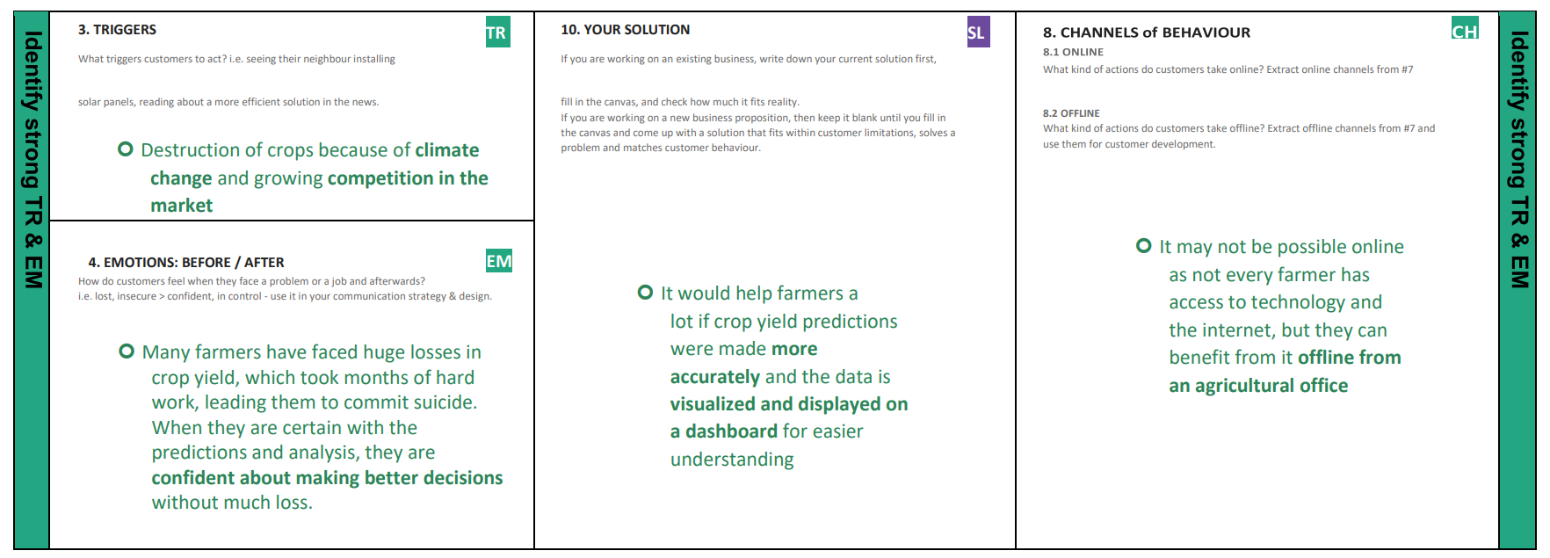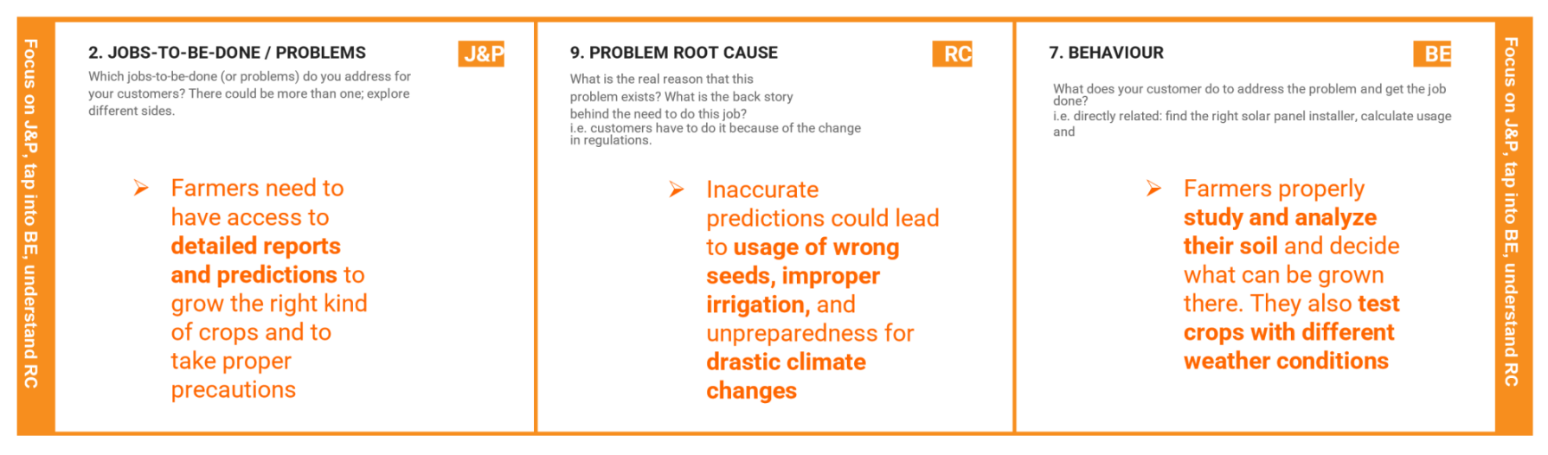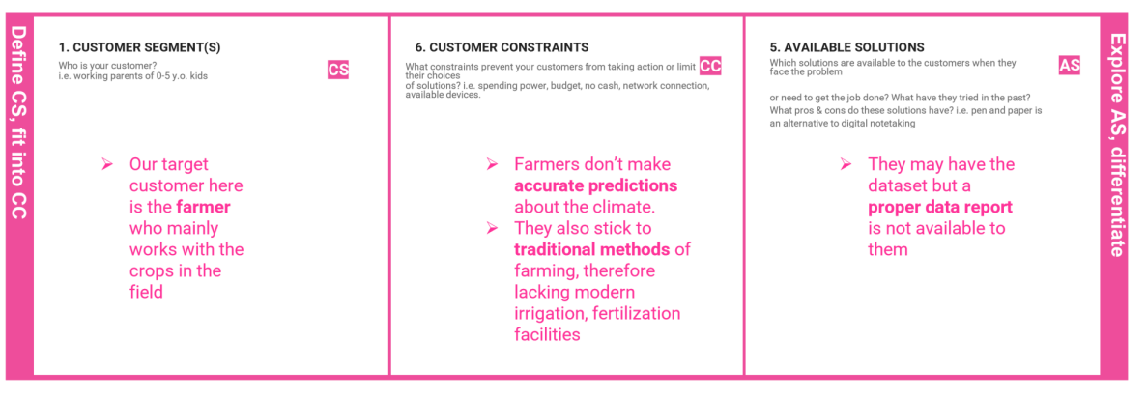 **Team ID: PNT2022TMID42593**